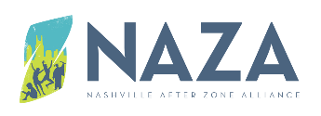
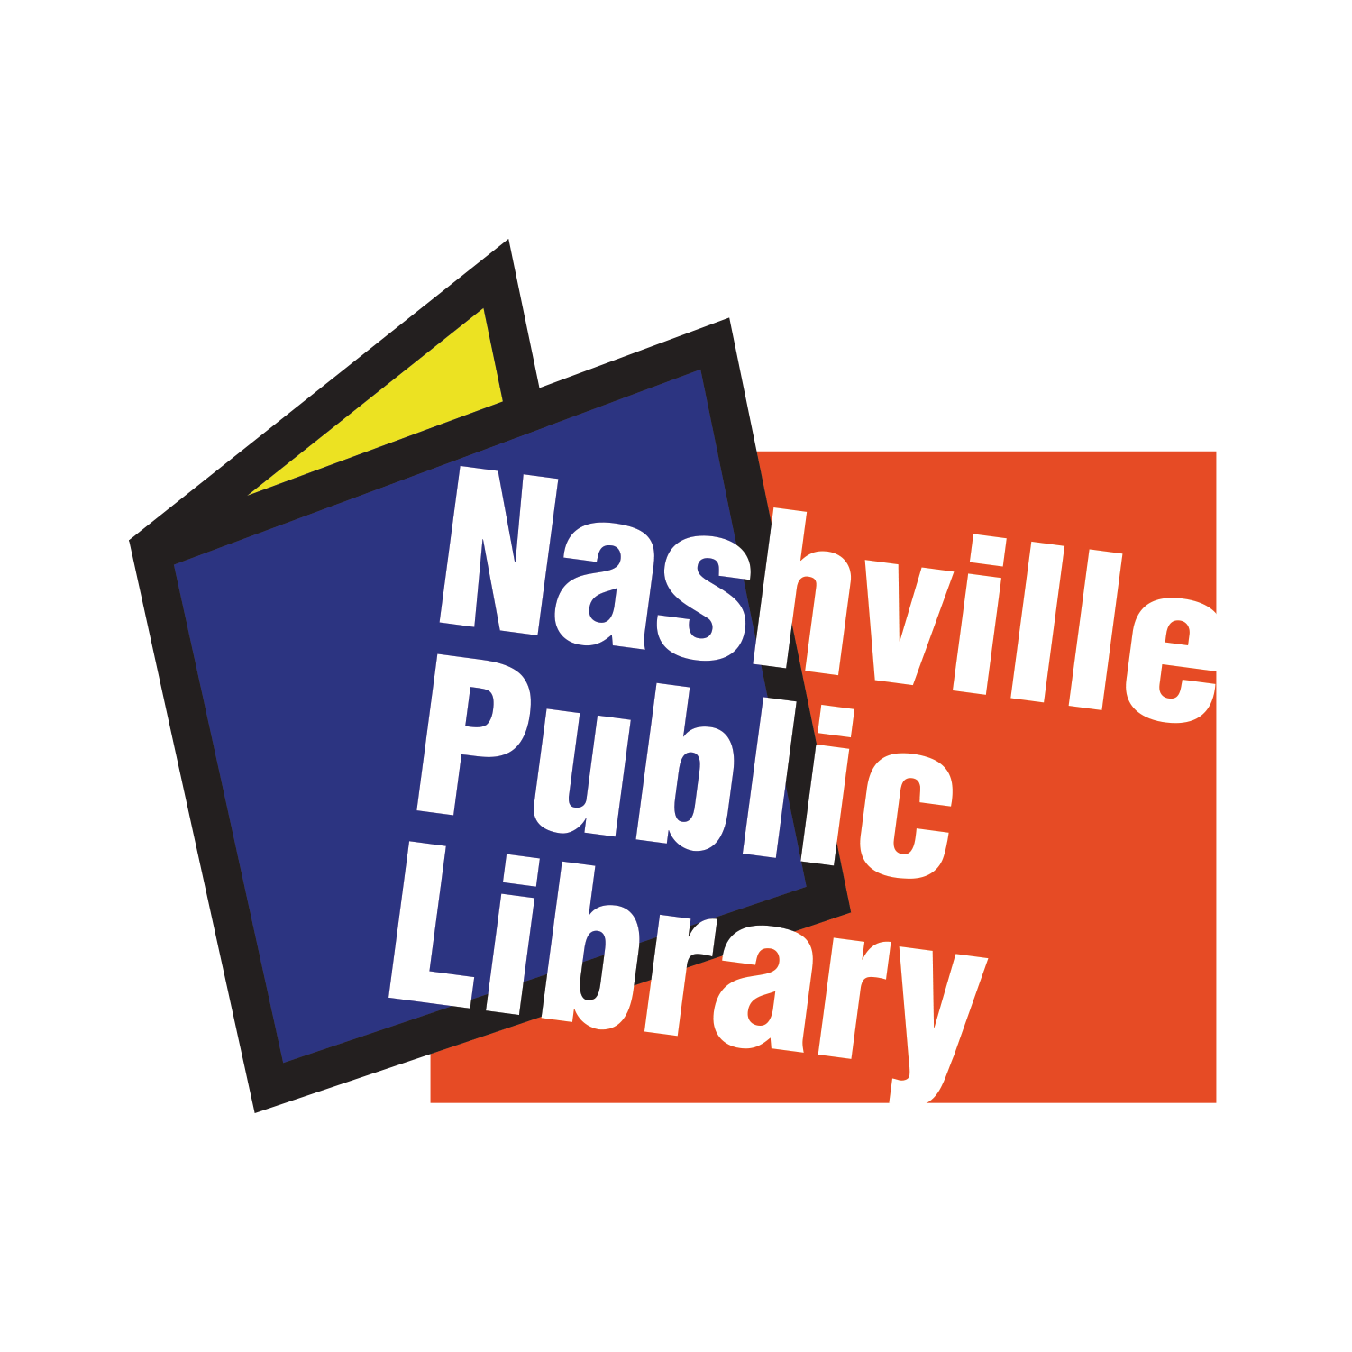

NAZA Strategy Development Consultant
Request for Proposals

Application deadline: Tuesday, October 13, 2020 at 5:00pm
Total number of hours estimated for this task is 140 hours at a rate of $60/hour.
Context
The Nashville After Zone Alliance (NAZA) is a partnership between the Nashville Public Library, Metro Nashville Public Schools, the Mayor’s Office, and more than 20 youth development organizations across Nashville. NAZA’s mission is to increase equitable access to afterschool and summer learning experiences that help Nashville youth thrive and develop to their full potential. We do this by funding youth development organizations to provide high quality, free-of-charge programs to middle school youth as well as by strengthening the capacity of the youth development community through professional development, evaluation services, and technical assistance to impact the learning experiences of youth.

In 2018, NAZA received two Federal grants to focus on the following:
- Assessing the needs of youth in Nashville,
- Determining the community assets that support youth in thriving,
- Creating a community-informed framework with youth-centric outcomes that would inform and guide the work of NAZA and its partners, as well as that of the larger Nashville community focused on work with children and youth.
NAZA partnered with Vanderbilt’s Peabody College to lead both the needs assessment and youth outcomes framework development process. NAZA and Peabody formed a community-wide Youth Development Working Group (YDWG) attended by over 25 agencies, including youth, the school district, non-profits, funders, and city government representatives. The group collectively led both the needs assessment and the outcomes framework creation. Additionally, Peabody hosted 20 focus groups with youth, caregivers, youth development professionals, city leaders, school leaders, and local funders and businesses, with the intention of defining what youth need to thrive in education, work, and life, plus the assets that exist in the Nashville community to support youth in thriving. The resulting 171-page Needs Assessment Report served as a guiding document for creating “Nashville’s Vision for Holistic Youth Development.”
Nashville’s Vision for Holistic Youth Development frames the 12 most critical skills/practices that youth need to thrive, based on the data from the focus groups and votes of the YDWG members as well as youth leadership groups in Nashville (Mayor’s Youth Council and NAZA’s Youth In Action!). In addition, the Vision frames 4 community assets deemed critical to support youth in thriving, along with associated definitions and levels (interpersonal, system, and societal belief) based on Bronfenbrenner’s ecological systems model. The Vision was adopted by the YDWG in May 2020 and will be publicly launched in October 2020. The Vision is accompanied by a toolkit with definitions of skills/practices and assets, guidance on how these look in practice, and resources.
Note: Because the Vision is not yet launched, it is not available for sharing publicly. However, the document is available for review upon request. NAZA will provide a link to access the document for limited number of days.
The Consultancy Scope
NAZA is looking to hire a consultant to support the development of the new system-wide NAZA Strategic Plan for 2021-2026.
NAZA has a dual mandate of:
- Investing funds in afterschool and summer programs for middle school youth citywide; and
- Strengthening the capacity of the youth development community through professional development, evaluation services, and technical assistance to impact the learning experiences of youth in general and social and emotional learning, in particular..
Additionally, NAZA’s strategic priorities include:
- Convening the Nashville community to strategically mobilize and leverage resources to collectively impact youth;
- Advocating for increased investment in holistic youth development; and
- Empowering youth through initiatives that cultivate leadership and life skills, connect them to positive relationships, and inspire their love for learning.
Going forward, NAZA will focus heavily on building the capacity of youth development organizations (NAZA-funded and affiliated partners especially) in our community to help Nashville children and youth thrive and develop to their full potential by working alongside these partners, other stakeholders, and youth to co-develop strategies for how to 1) advance the 12 practices and four assets through formal and informal education, innovative approaches, and toolkits, and 2) measure progress on implementing the Vision. Throughout the next 5 years, NAZA will work collaboratively with NAZA- funded and affiliated partners, youth, and other stakeholders to support the integration of the practices and assets into afterschool and summer program design, delivery, and evaluation of youth outcomes and assets. The new strategic plan will be heavily informed by the Community Youth Needs Assessment and the Vision. The plan will evolve over time to adapt to collaboratively-determined emergent needs and to incorporate meaningful implementation strategies for the practices and assets with a focus on how NAZA as a system can support community youth and adults in co-creating the conditions that help children/youth thrive in alignment with the Vision. Ultimately, these efforts will support children/youth in skill and asset development.
Access and Equity
NAZA was established to increase Nashville youth’s equitable access to afterschool programs. The core purpose of investing public and private funding in afterschool and summer programs is to ensure that youth from families without the resources for afterschool enrichment programs have access to high-quality programs at no cost to families. Longitudinally, over two-thirds of youth that have attended NAZA-funded programs were from families that self-identified as economically disadvantaged. Demographically, on average, 70% of attendees in NAZA-funded programs identified as Black, 15% as Latino, 10% as white, and 5% as Asian.
Given the ongoing urgent need to re-emphasize the importance of equity in general and racial equity in particular, NAZA would like to reiterate its commitment to advancing equitable access to afterschool and summer programs and expanding equity within our system and network, and in all future engagements. It is critical that the consultant apply a strong equity lens while supporting the development of the next strategic plan and related components. NAZA can provide further details on how equity is conceptualized in Nashville’s Vision for Holistic Youth Development and provide notes from the NAZA team’s recent discussions on equity to help guide the process.

Timeline and Deliverables
Deliverable | Timeline | Estimated number of hours | Notes
Initial document review, data collection (design, administration and analysis). The data collection should include a process to map assets within the NAZA system, especially those of partners and youth, and assets that are external to NAZA but that could support NAZA’s work. | October 20th through November 27th | 45 | NAZA team, youth, partner, and Leadership Council input sought through meetings and surveys.  NAZA team, including Youth In Action!, must be consulted regularly, between drafts and final versions.  NAZA Chief Executive will be in regular communication and review mode throughout the entire process. It is essential that the strategic plan builds on the assets of the NAZA team, , youth, partners, and the greater community.
Theory of Change | 1st draft-December 20  Final- January 20 | 15 | Because the narrative of afterschool is changing, at least for NAZA, there is a need for a well-designed theory of change (TOC) which provides a big picture of youth development, holistic learning, and afterschool and summer programs’ role in youth development and holistic learning. The TOC should show the pathways leading to change, and describe how and why the change should happen. The TOC flows with a logic of “if we do X… Y, Z will happen” and keeps youth in the center.
Strategic Map with a focus on equity | 1st draft-December 20  Final- January 20, 2021 | 15 | The Strategic Map must define the key strategic areas that NAZA as a system commits to prioritize for the next strategic cycle. Currently there are 5 strategic priority areas, with some of them remaining the same.  This document will be a one pager that defines our mission, vision, strategic priorities while showing the big picture of the system work.
Results Framework with a focus on equity | 1st draft January 20th, 2020  Final -February 15th 2021 | 25 | The Results Framework will define 1-2 big strategic goal/s for NAZA as a system and will detail several objectives, as well as intermediate and long-term results for each.
Full Strategic Plan | Draft: March 15th, 2021  Final: April 30th, 2021 | 25 | The full Strategic Plan will include the Theory of Change, the Strategic Map and the Results Framework. It will include the full text write-up with a robust, detailed section on assumptions and risks. The resulting plan will advance equity across all strategic priorities. Additionally, the plan will detail how assets inform the abovementioned components.
Log Frame with an indicator tracking table for Year 1 implementation | May-June 2021 | 15 | This deliverable is related to Year 1 implementation of the new strategy. The goal of the Log Frame with an indicator tracking table is to assist in NAZA’s compilation of a detailed annual plan and to enable proper implementation alongside monitoring of success in Year 1 (FY 22).

Minimum Qualifications:
- Master’s degree in social sciences, education, human and organizational development or related discipline.
- At least 5 years of consulting experience in strategy development (preferably in one of the related disciplines above) with a strong focus on equity.
- Proven experience in designing and administering mixed-method data collection approaches (e.g. surveys and focus groups).
- Professional skills of quantitative and qualitative data analysis and data informed planning.
- Proven experience in designing theories of change, results framework, strategic plans, etc.
- Excellent communication and professional writing skills.
Preferred Qualifications:
- PhD;
- Knowledge of or experience in youth development; Conflict management experience; and/or
- Prior experience consulting with local government entities.
To Apply:
Please email the following documents to Anna Harutyunyan, NAZA Chief Executive, at anna.harutyunyan@nashville.gov
- CV
- Cover letter
- 1-page proposal with methodology for this task.

